DAILY ONLINE ACTIVITIES SUMMARY
Date: |  | 3/06/2020
Name of the Faculty |  | Ankitha Shetty
No. of Students Allotted for monitoring |  |  |  | 16
Progress |  |  |  | Good
Whether collected report from all the allotted students |  |  |  | 12 students are updating daily  2 students are involved in online activity.  2 students are not uploading anything.
Online Test Summary
Subject | Operation Research
Semester |  |  |  | Duration
No. of students Taken |  |  |  | Passing %
Certification Course Summary
Course |  | - webinar on Python and its applications  - webinar on App Development and Embedded Systems-Co-Design Consideration
Certificate Provider |  | 1) SJBIT  2)BIT |  | Duration |  | 1 hour
Coding Challenges
Problem Statement: C Program to Generate Prime Numbers in an Interval
Status: 37
Uploaded the report in Github |  |  |  | Yes
If yes Repository name |  |  |  | https://github.com/ankishetty91/ankitha-daily-report
Uploaded the report in slack |  |  |  | Yes

Certification Course Summary
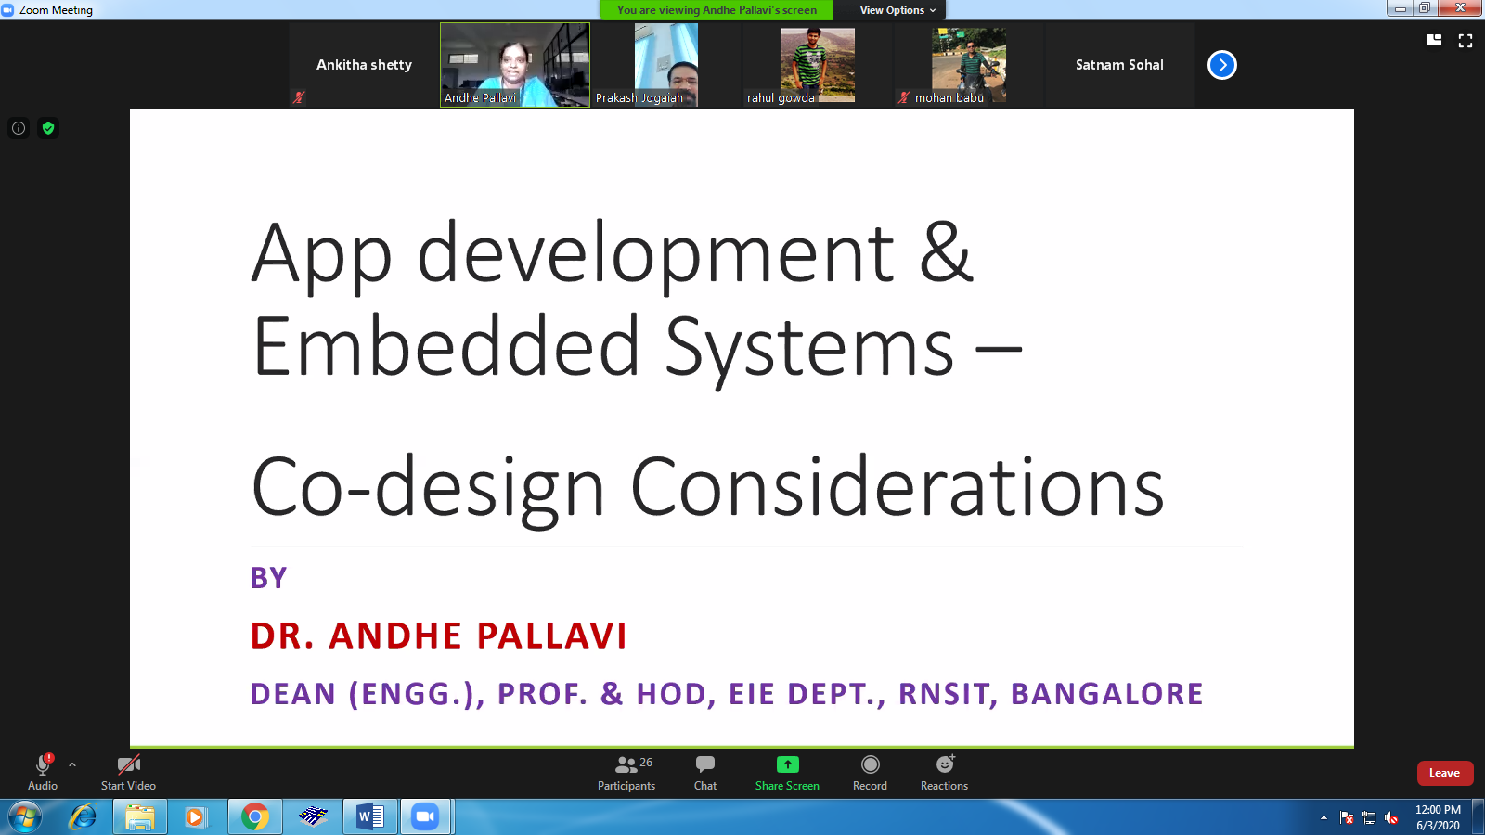

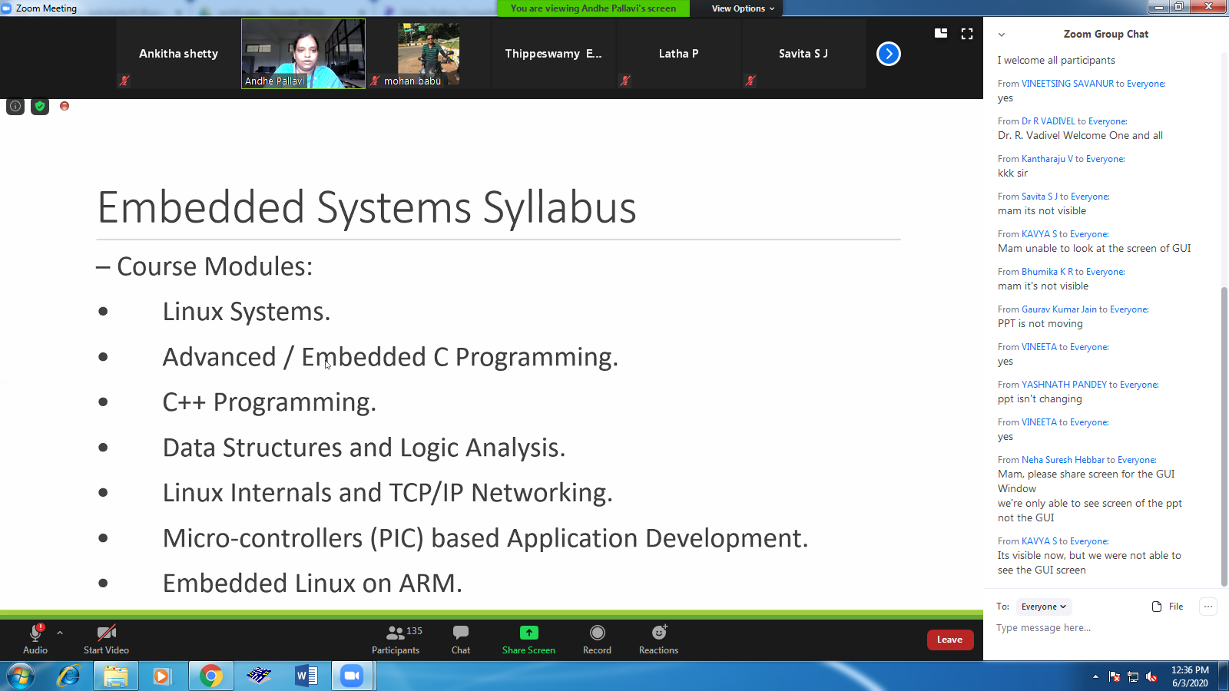

Students Report:
